VEX Applications

Scan the QR Code to complete the application!

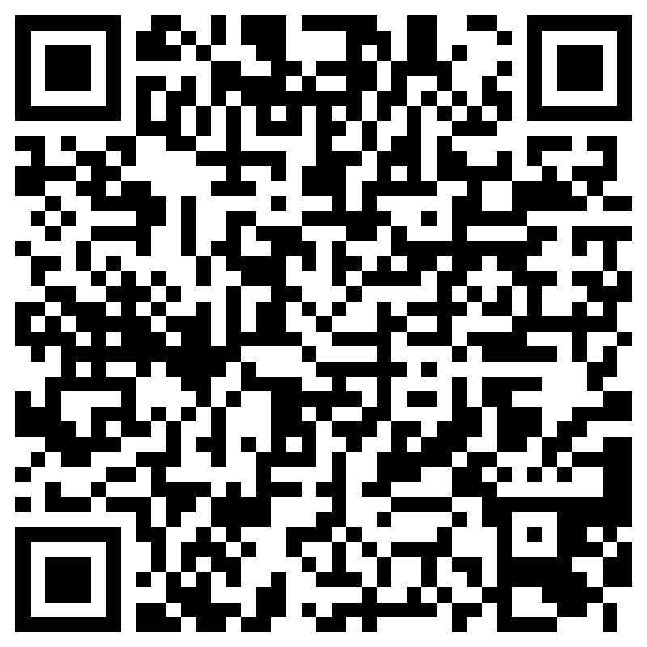
https://forms.office.com/r/yk7WyHKUvh

